**Lesson 13 Demo 2**

**Configuring Jenkins backup and restore**

**Objective:** Install Thin backup Jenkins’s plugin for configuring backup and restoration.

**Tools required:** Jenkins CI Tool

**Pre-requisites:** You need to have Jenkins up and running.

Steps to be followed:

1. Login to Jenkins master server and then perform bounce activity for Jenkins

**Step 1: Login to Jenkins master server and then perform bounce activity for Jenkins**

1. Login to Jenkins CI tool with admin user and navigate to Manage Jenkins and Manage Plugins.

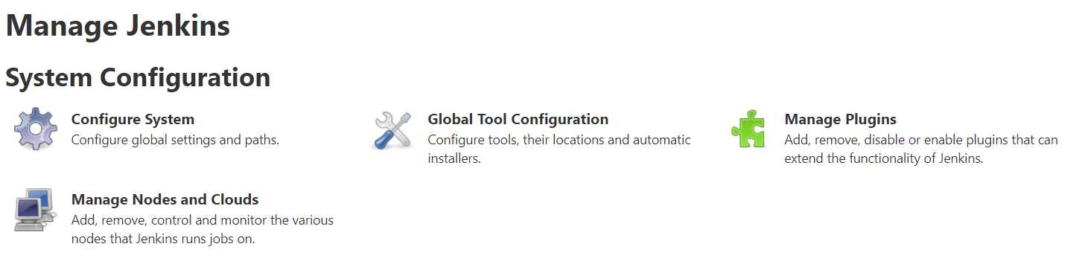

1. Then navigate to Available tab and search for **thin backup** plugin.

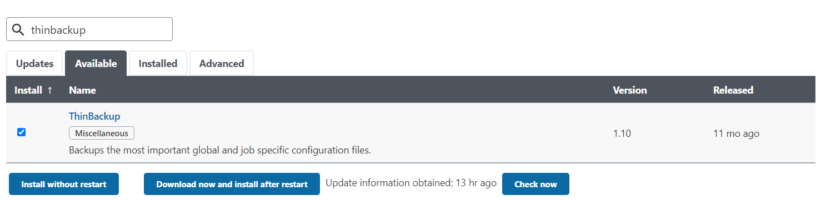

1. Now user need to configure thin backup Plugin in Jenkins. Login to Manage Jenkins 🡪 Configure System.

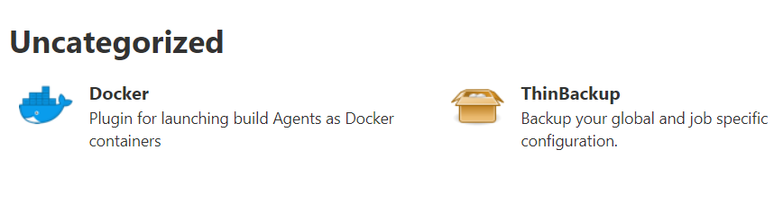

1. Below options would be displayed while configuring backup plugin in Jenkins.

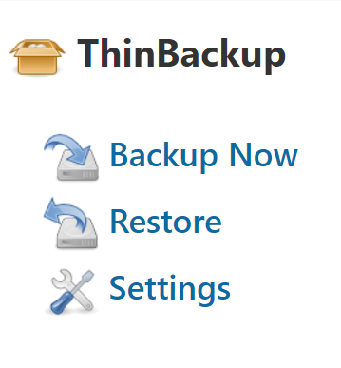

1. Perform configuration for backup directory and backup schedule when backup would be triggered automatically. This plugin supports both manual and automated backups.

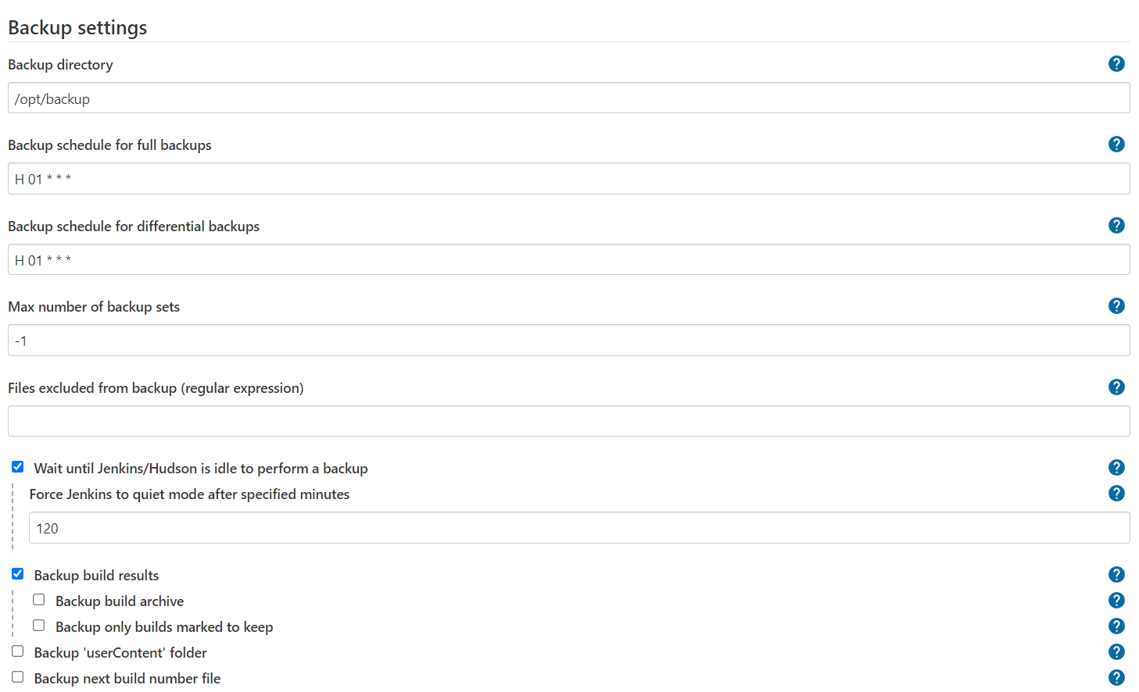

1. Once Backup is taken it would be displayed in drop down menu in Restore configuration screen.

